**Name: Varad Patil**

**Batch: A2**

**Roll no: 120A2036**

**EXPERIMENT NO. 2**

**TO PLOT REFRACTIVE INDEX PROFILE OF STEP INDEX AND GRADED INDEX FIBER**

**EXPERIMENT NO. 2**

**TO PLOT REFRACTIVE INDEX PROFILE OF STEP INDEX AND GRADED INDEX FIBER**

**OBJECTIVE:**

The objective of this experiment is to plot

1. the refractive index profile with n1=1.5, ∆ = 0.01 and core radius=30 micrometer for Step Index Fiber
2. the refractive index profiles from n1 to n2 as a function of radial distance r ≤ a for graded index fibers that have α values of 1 to 10. Assume the fibers have a 30 mm core radius, n1 = 1.5 and ∆ = 0.01.

**SOFTWARE USED: Python**

**THEORY:**

Optical fiber is the technology associated with data transmission using light pulses travelling along with a long fiber which is usually made of plastic or glass. Optical fibers are also unaffected by electromagnetic interference. The fiber optical cable uses the application of total internal reflection of light. The fibers are designed such that they facilitate the propagation of light along with the optical fiber depending on the requirement of power and distance of transmission.

The types of optical fibers depend on the refractive index and mode of propagation of light.

The classification based on the refractive index is as follows:

* **Step Index Fibers:**It consists of a core surrounded by the cladding, which has a single uniform index of refraction.
* **Graded Index Fibers:**The refractive index of the optical fiber decreases as the radial distance from the fiber axis increases.

The classification based on the mode of propagation of light is as follows:

* **Single-Mode Fibers:**These fibers are used for long-distance transmission of signals.
* **Multimode Fibers:**These fibers are used for short-distance transmission of signals.

Depending upon mode of propagation and refractive index of the core, fibers are classified as:

* Step index-single mode fibers
* Step index-Multimode fibers
* Graded index-Multimode fibers

The optical fiber with a core of constant refractive index n1 and a cladding of a slightly lower refractive index n2 is known as step index fiber. This is because the refractive index profile for this type of fiber makes a step change at the Cylindrical fiber.

The refractive index profile of Step Index fiber may be defined as:



Graded index fibers do not have a constant refractive index in the core but a decreasing core index n(r) with radial distance from a maximum value of n1 at the axis to a constant value n2 beyond thecore radius a in the cladding. This index variation may be represented as:



Where ∆ is the relative refractive index difference and α is the profile parameter which gives the characteristic refractive index profile of the fiber core. The above equation which is a convenient method of expressing the refractive index profile of the fiber core as a variation of α allows representation of the step index profile when α = ∞, a parabolic profile when α = 2 and a triangular profile when α = 1. This range of refractive index profile is illustrated in Figure.

**Code:**

import math

import numpy as np

import matplotlib.pyplot as plt

n1 = 1.5

delta = 0.01

a = 30 # core radius

a1 = 125

n2 = n1*math.sqrt(1 - 2*0.01)

r = np.linspace(-(a1+1), a1, a1+1)

n = []

for i in r:

  if i < a and i > -a:

    n.append(n1)

  else:

    n.append(n2)

plt.plot(r,n)

plt.xlabel('radial distance in micro meter')

plt.ylabel('refractive index n(r)')

plt.title('Refractive Index of Step Index')

plt.show()

n1 = 1.5

delta = 0.01

a = 30 # core radius

a1 = 125

n2 = n1*math.sqrt(1 - 2*delta)

r = np.linspace(0, a1, a1+1)

for alpha in range(1,11):

    n1 = 1.5

    n = []

    for i in r:

        if i < a:

            n.append(n1 * math.sqrt(1 - 2 * delta * (i / a) ** alpha))

        else:

            n.append(n2)

    plt.plot(r, n, label=f'Alpha={alpha}')

plt.xlabel('radial distance in micrometer')

plt.ylabel('refractive index n(r)')

plt.title(' Refractive Index of Graded Index')

plt.legend()

plt.show()

**Output:**

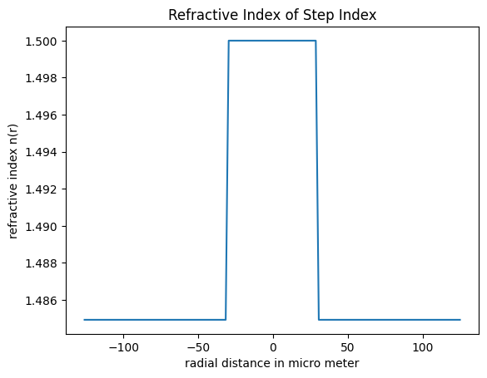

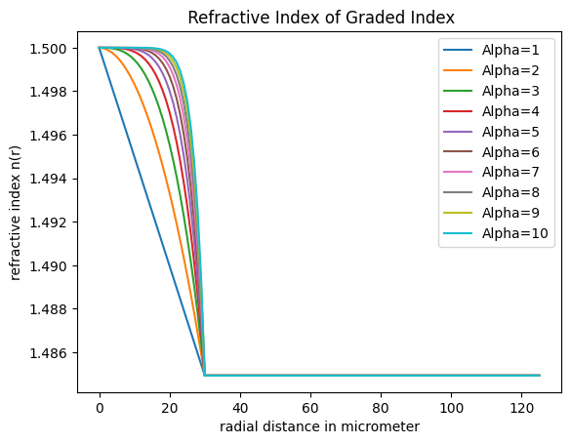

**CONCLUSION:**

**For Single mode of communication, Step Index fiber is used and for Multiple mode Graded Index is used. From Step Fiber we can see that R.I. is high for the core diameter, and for graded index R.I. decreases as alpha increases. It means that the R.I decreases as distances increases from core.**